# Department of Computing

# Fundamental of Computer Programming

# Class: SE-7B

# Lab 9: For loops

# Date: 7th November, 2016

# Time: 2pm-5pm

# Instructor: Muhammad Muddasir Malik

# Lab 9: For Loops

# Introduction

A loop statement allows us to execute a statement or group of statements multiple times and following is the general form of a loop statement in most of the programming languages

**Tools/Software Requirement**

Python IDLE

**Tasks:**

1. Implement a Fibonacci series upto 10th term. Your code must print this output:

0 1 1 2 3 5 8 13 21 34

1. Write a program that uses for statements to print the following patterns separately. All asterisks (*) should be printed by single statement of the form print(‘*’).  
     
   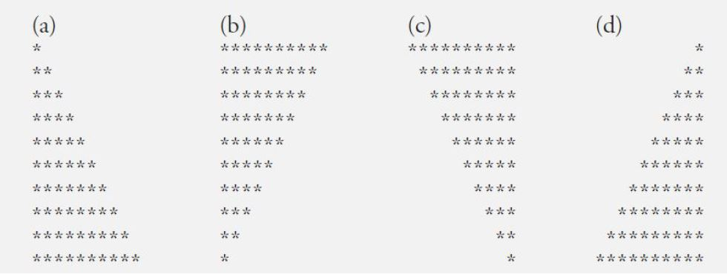

1. Write a program that prints the following diamond shape.

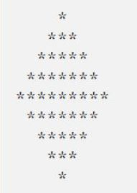

1. Read a 3x3 matrix from the user and find its transpose. Print the original and the transpose matrices on the screen.
2. Read two 3x3 matrices from the user and find their product. Print the original matrices and the product on the screen.
3. Read the size of the matrix from the user. Populate it with data from the user. Print the original and the transpose matrices on screen.